Lise Soulé

Dr. John Dorsey

ENVS 401 Senior Seminar

May 8, 2015

**Final Report:**

**Air Quality Egg Research**

**Introduction:**

Although people can control what they eat and what they drink, they do not have a choice on the air they breathe. However, according to the World Health Organization, about two million people die prematurely every year from the effect of polluted air (World Health Organization, 2014). So unless we are scientists in our laboratory, how can we know that the air we are constantly breathing is clean?

Meteorologists and other researchers often measure air quality in a region at discrete individual sites and at discrete times. However, access to air quality measurements made in large city such as Los Angeles made at numerous sites continuously over the region would allow many new questions to be probed. The availably of low cost data eggs allows for the creation of such a network of sensors.

Indeed, the data eggs have been conceived in order to create a network of open source sensors and a data platform via web apps, mobile apps, visualizations, and more. The sensor system has been designed to allow anyone to collect very high-resolution readings about concentrations of air pollution such as nitrous oxide, a precursor to ozone, or again atmospheric concentrations of carbon dioxide that is a primary driver of climate change. In addition, the sensors can also provide more basic measurements such a temperature and humidity.

Initial work to create such networks has been done in a few cities such as Boston, New York, and Louisville. However, the interface they created is too complicated for all users and seems to be addressed for a different audience.

We have set out to create such a network in the Los Angeles area using schools, and other citizen science groups, to monitor individual data eggs on the network. The goal of the network being to create a user friendly interface for all accessing the site to view results obtained as well as retrieve raw data collected for studying additional research questions. The interface should include the creation of an interactive map to easily interpret the results visually and allows audiences to get the raw data they need by sensors and time, as well as to interpret easily the results visually.

**Methods:**

We used the Air Quality Eggs (AQE), from Wicked Device (<http://shop.wickeddevice.com/resources/air-quality-egg/>), to monitor the air quality. The advantages of AQE is that they use a sensor system designed to collect very high-resolution readings, accessible to all due to its simplicity of use and its low cost.

AQE are composed of two units: the sensors and the receiver. The outdoor sensors take regular readings. Indeed, they have a radio frequency transmitter that sends the data wirelessly to an egg-shaped base station inside. The egg base station receives the wirelessly transmitted data from the sensor box outside and it then relays that data to the Internet via a wired Ethernet connection. In other words, the egg acts as a user interface. To finish, the data is sent to Internet via an open data service named Xively. This interface stores and provides free access to the data, including graphs and generating triggers for tweets and SMS alerts.

Through this research, AQE were placed on campus and its neighborhood, and were monitored for the following measurements and concentrations: temperature, humidity, nitrogen dioxide, carbon monoxide, dust, ozone, and volatile organics. In addition, various studies have been conducted on the precision, accuracy, and the stability of the data eggs.

**Results and Discussion:**

Analyze of Data Eggs Already Within the LA Network

The first step of this project was to analyze the data eggs that were already within the Los Angeles network. As showing in the map bellow (Figure 1), a total of 25 eggs were registered into the Air Quality Egg network, however only 5 of them were actually connected and recorded data. Two of those eggs were classified as indoor eggs, while the other three were classified as outdoor eggs.

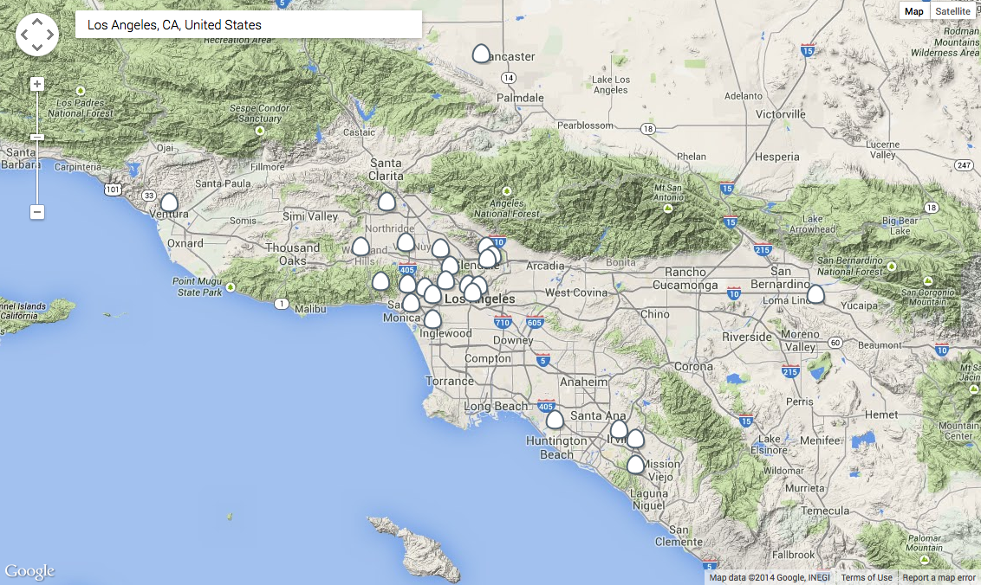

**Figure 1.** *Data Egg Network, City of Los Angeles*

In order to analyze the 5 active Data Eggs of the LA network, four different variables such as the temperature, humidity, nitrogen dioxide and carbon monoxide were recorded during 4 consecutives days at a rate of 3 data points per day (values recorded once on the morning, once on the afternoon, and once on the evening via [www.airqualityegg.com](http://www.airqualityegg.com)). Note that the data retrieved from airqualityegg.com can only be done at current time t. There is no possibility to retrieve previous data. A comparative study of the indoor eggs was then done, as well as a comparative study of the outdoor eggs.

Comparative Study of Indoor Data Eggs:

Within the LA network, only two eggs were currently recording indoor air quality. The first one was named Encino_CA_001 and was located at the Sepulveda Basin Recreation Area. The second one was named Los Angeles (Near Beverly Hills) Test Egg and was located at the intersection of Martel Avenue and W 2nd Street (near the Grove).

By doing a comparative study of those two eggs, the following observations have been made. Regarding first the temperature sensors (Figure 2), the Encino egg results demonstrated a more linear trend than the Los Angeles egg, with only 2°C of fluctuation maximum during a day. However, the Los Angeles egg demonstrated a more oscillated trend with maximum temperatures occurring at the afternoon, and minimum temperatures occurring at night. The small fluctuation of temperature throughout the day is a typical indoor characteristic, as building might be equipped with air conditioning and consequently temperature is constantly regulated. However, the oscillation observed in the second egg during the day is more of an outdoor characteristic.

**Figure 2.** Los Angeles *Indoor Eggs Network: Temperature*

Regarding the humidity sensors (Figure 3), both eggs demonstrated a constant trend over time. However, 40% of humidity’s difference is observed between the two eggs. The Encino egg humidity value is about 40% in average, which is very more likely to be accurate than the Los Angeles values. Indeed, the Los Angeles egg humidity value is about 1% in average, which is almost physically impossible. It seems that the Los Angeles humidity sensor needs to be re calibrated accordingly in order to give accurate values. The same observations are made regarding the nitrogen dioxide and carbon monoxide sensors (Annex 1 and 2).

**Figure 3.** *Los Angeles* *Indoor Eggs Network: Humidity*

Comparative Study of Outdoor Data Eggs:

Within the LA network, only three eggs were currently recording outdoor air quality. The first one was named Paul’s Test Egg and was located in Woodland Hills. The second one was named Air Quality Egg and was located in between Glendale and Pasadena. Finally the third one was named Lancaster-CA-USA-001 and was located north LA in Lancaster, close to Quartz Hill.

By doing a comparative study of those three eggs, the following observations have been made. Regarding first the temperature sensors (Figure 4), the three eggs demonstrated oscillated trends with maximum temperatures occurring at the afternoon, and minimum temperatures occurring at night. These trends are typical characteristic of outdoor temperatures and consequently all of the three temperature sensors seem accurate.

**Figure 4.** **Figure 3.** *Los Angeles* *Outdoor Eggs Network: Temperature*

Regarding the humidity sensors (Figure 5), two of the three eggs demonstrated a constant trend over time with values in between 30 and 35%. However, the Air Quality egg humidity values fluctuate drastically from 1 to 100%. It seems that this egg humidity sensor needs to be re calibrated accordingly in order to give accurate values. The same observations are made regarding the nitrogen dioxide and carbon monoxide sensors (Annex 3 and 4). However, it seems that Lancaster and Air Quality NO2 and CO sensors are well calibrated, and that Paul’s NO2 and CO sensors need to be calibrated accordingly. In conclusion, only the Lancaster sensors seem to be all properly calibrated.

**Figure 4.** *Los Angeles* *Outdoor Eggs Network: Humidity*

Comparative Study of Temperature and Humidity Outdoor Sensors with an Outside Source

The second step of this project was to compare and analyze the temperature and humidity data from an outdoor egg with data from another source. In order to do so, one egg was located on LMU Campus, outside Seaver building. Temperature and humidity measurements were recorded during 34 consecutive days at a rate of 8 data points per day (values were retrieved from <https://xively.com/feeds/163188704>). In addition, LAX temperature and humidity measurements were also recorded from a different source (<http://www.wunderground.com/history/airport/LAX/2014/7/1/DailyHistory.html>) during the same period of time and at the same rate. A comparative study of the outdoor egg data with an outside source data was then done.

By doing a comparative study of those two devices, the following observations have been made. Regarding first the temperature (Figure 6), the two devices demonstrated oscillated trends that are regular fluctuation of temperature throughout time. However, it cannot be determined that the highest picks from the egg are synchronized with the highest picks from the comparative device. In addition, a difference of about 40°F is observed between the two devices, with the egg temperatures fluctuating from 110 to 120°F, and the comparative temperature fluctuating from 60 to 80°F. With such elevated temperatures recorded from the egg, it is clear that the temperature sensor need to be re calibrated.

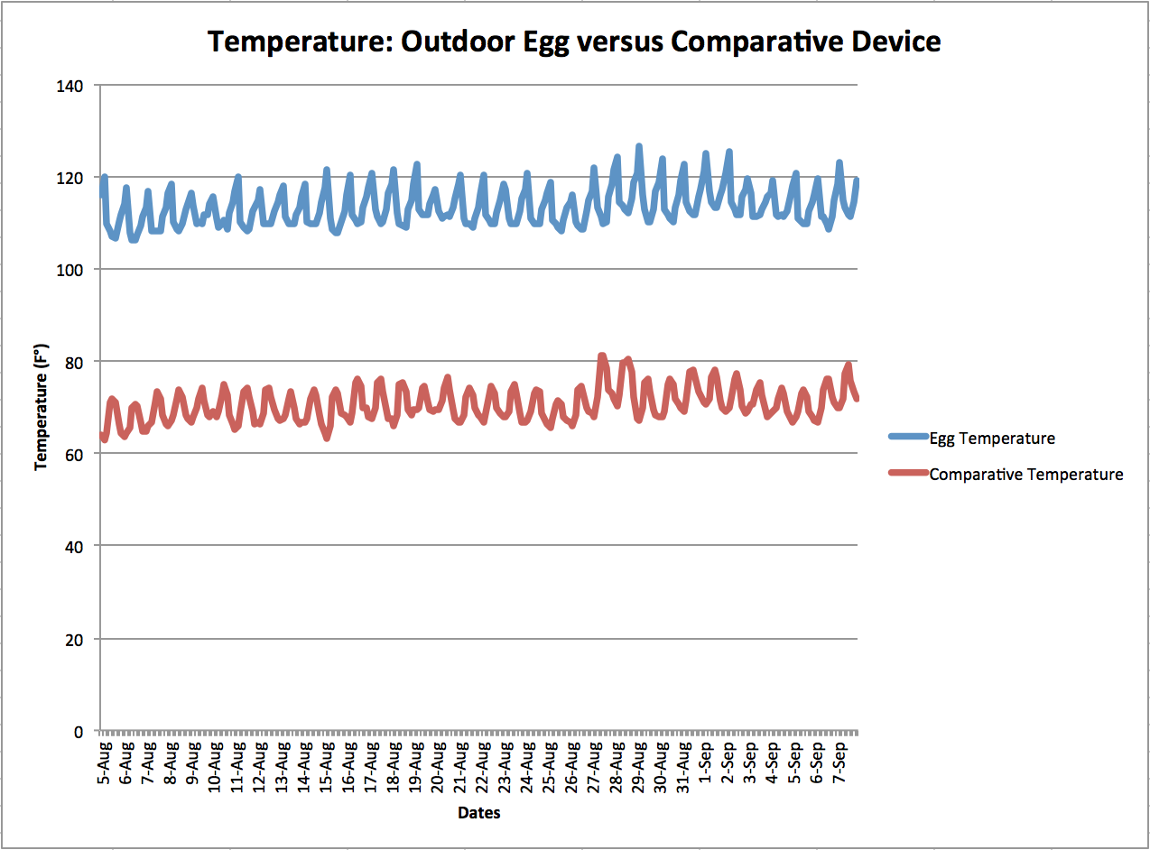

**Figure 6.** *Outdoor Egg versus Comparative Device: Temperature*

For humidity (Figure 7), the same observations done regarding temperature are made. Indeed, the two devices demonstrated oscillated trends that are regular fluctuation throughout time. However, it cannot be determined that the highest picks from the egg are synchronized with the highest picks from the comparative device. In addition, a difference of about 35% is observed between the two devices, with the egg humidity fluctuating from 30 to 50%, and the comparative humidity fluctuating from 60 to 90%.

To finish, a general observation from these graphs is that as humidity depends of temperature. Indeed, higher the temperature, lower is the humidity; and lower the temperature, higher is the humidity.

|  |
| --- |
|  |

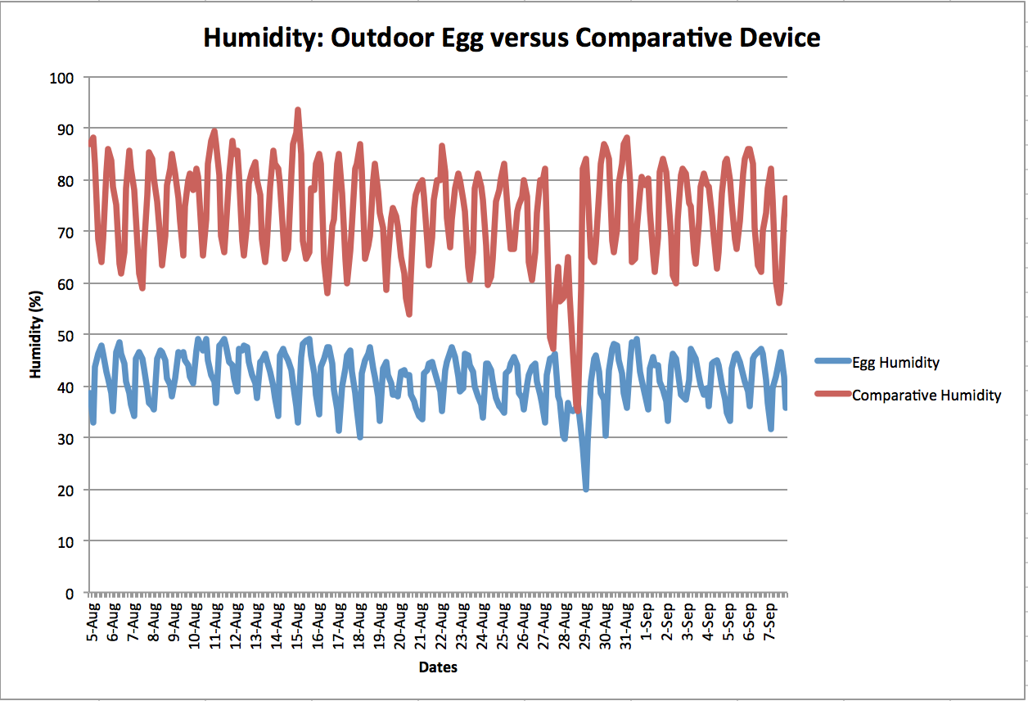

**Figure 7.** *Outdoor Egg versus Comparative Device: Humidity*

Study on Precision, Accuracy, and Stability of Data Eggs

The third step of this project was to conduct a study on precision, accuracy, and stability of the data eggs. In order to do so, three eggs were all located at the same place on LMU Campus, inside of Seaver building, in Dr. Landry’s office to be exact. We will call the eggs JML001, JML002, and JML003. For all the sensors, meaning temperature, humidity, nitrogen dioxide, carbon monoxide, dust, ozone, and volatile organics, the data was retrieved from 8 am to 10 am for three different days (values were retrieved from <http://shop.wickeddevice.com/eggdata/download_data.php>). The data was retrieved twice, one time at a rate of one data point per 5 minutes (for a total of 24 points), and another time at a rate of one data point per minute (for a total of 60 points). From there, means and precisions were calculated for each egg and variable, and summarized in a table (Annex 5).

The main observations to retain from this table are the following. First, the mean and precision results do not change significantly depending on the rate of data points retrieved (1 data point per 5 min or 1 data point per minute).

Secondly, for all of the three eggs, the precision for temperature and humidity were both good as it was about 0 (with a maximum of 0.38). Regarding the precision for nitrogen dioxide, JML002 and JML003 results were good fluctuating between 0 and 3, while the results for JML001 were significantly higher but became better over time as it fluctuated from 11 to 4. In addition, the precision for carbon monoxide and dust were very high for all of the three eggs, fluctuating from about 39 to 1200, and 116 to 314 respectively. Regarding the precision for ozone, the results demonstrated disparity. Indeed, the precision was good for JML001 as it was about 0 (with a maximum of 0.44). In another hand, the JML002 ozone sensor was not working and consequently did not provide any data, while the precision of JML003 was higher than JLM001 as it fluctuated from 7 to 11. To finish, JML002 and JML003 precision for volatile organics were both good as it was about 0 (with a maximum of 0.3), while the results for JML001 were a little higher and fluctuated from about 2 to 5.7.

In conclusion, for all three eggs, the temperature, humidity, and volatile organics sensors seem to be precise, while the carbon monoxide and dust sensors are not precise at all. Moreover, the nitrogen dioxide sensors were also precise except for JML001, and only JML001 sensor was precise regarding the ozone results.

Thirdly, even if accuracy could not have been determined, a comparison of the means helped us to understand their behavior to one another. Theoretically, the means for each egg should have been the same or very similar since the three eggs were placed into the same environment. However, that was not the case. Indeed, in general JML001 mean had a tendency to be significantly higher than JML002 and JLM003 (Figure 8), except for the temperature and ozone sensors (Figure 9). Additionally, JML002 and LML003 means were significantly close for all the sensors except for nitrogen dioxide and dust (note that JML002 ozone sensor was not working so no comparison was made) (Annex 6 to 10). To finish, even if the results differed from one egg to another, the means of each egg remained significantly constant over time. In conclusion, the difference in these results indicates an issue with the sensors’ calibration.

**Figure 8.** *Three Eggs Humidity Mean Comparison*

**Figure 9.** *Three Eggs Temperature Mean Comparison*

Comparative Study of the Three Eggs

The fourth and last step of this project was to compare and analyze the three different eggs for each of the sensors. In order to do so, one egg was located on LMU Campus, inside of Seaver building, in Dr. Landry’s office to be exact; while the two others eggs were located in LMU’s neighborhood, in a private house at Holy Cross Place. We will call the eggs Egg 1 (LMU Campus), Egg 2, and Egg 3 (Holy Cross). For all the sensors, meaning temperature, humidity, nitrogen dioxide, carbon monoxide, dust, ozone, and volatile organics, the measurements were recorded during 14 consecutive days at a rate of 8 data points per day (values were retrieved from <https://xively.com/feeds>). That experiment was repeated a second time, at a difference that all of the three eggs were now located at Holy Cross.

By doing a comparative study of those two devices, the following observations have been made. Regarding the first experiment, where Egg 1 was located on Campus while Egg 2 and Egg 3 were located on Holy Cross, temperatures demonstrated oscillated trends that are regular fluctuation throughout time for both Egg 2 and Egg 3, but not for Egg 1 (Figure 10). In addition, Egg 2 and Egg 3 had exactly the same results over time, while Egg 1 showed inferior values being recorded (about 5°C of difference in average). For humidity (Figure 11), the same observations done regarding temperature are made. However, the three eggs did not demonstrated oscillated trends that are regular fluctuation throughout time. Moreover, a general observation made in earlier steps of this project was confirmed; humidity depends of temperature. Indeed, higher the temperature, lower is the humidity; and lower the temperature, higher is the humidity. To finish, nitrogen dioxide and carbon monoxide sensors demonstrated the same tendency that the one observed with humidity: Egg 2 and Egg 3 had very similar results over time, while Egg 1 showed superior values being recorded (Annex 11 and 12). Dust results did not demonstrated any correlation between the three eggs (Annex 13) and no comparison for ozone and volatile organics could have been made, as the sensors were not working in all three eggs (Annex 14 and 15).

**Figure 10.** *First Three Eggs Comparison: Temperature*

**Figure 11.** *First Three Eggs Comparison: Humidity*

Regarding the second experiment, where all of the three eggs were located on Holy Cross instead, temperatures demonstrated oscillated trends that are regular fluctuation throughout time for all three eggs (Figure 12). In addition, Egg 2 and Egg 3 had exactly the same results over time, while Egg 1 showed inferior values being recorded (about 2 to 5°C of difference). For humidity (Figure 13), the same observations done regarding temperature are made. However, the three eggs did not demonstrated oscillated trends that are regular fluctuation throughout, and Egg 1 showed superior values of about 10% more than Egg 2 and 3. To finish, nitrogen dioxide sensors behaved very similarly to humidity (Annex 16); while carbon monoxide sensors demonstrated the same results over time for all three eggs (Annex 17). Dust results did not demonstrated any correlation between the three eggs (Annex 18) and no comparison for ozone and volatile organics could have been made, as the sensors were not working in all three eggs (Annex 19 and 20).

In conclusion, Egg 2 and Egg 3 demonstrated to have very similar values for most of the sensors, while Egg 1 demonstrated to have generally higher values. In such experiment, the ideal results would have been to find for all the three eggs and for all sensors the same data. However, it is not what happened and consequently we can conclude that first, Egg 2 and Egg 3 seem probably more accurate than Egg 1, and that secondly the sensors need to be re calibrating before re attempts such an experiment.

**Figure 12.** *Second Three Eggs Comparison: Temperature*

**Figure 12.** *Second Three Eggs Comparison: Humidity*

**Conclusion:**

In conclusion, a lot has been learned about the Air Quality Eggs and their functionality. Multiple testing demonstrated that the egg’s calibration was an important issue in order to have accurate and precise data. Indeed, beside the temperature and humidity sensors that demonstrated to give pretty good results, the other sensors did not give any meaningful data as the eggs’ values contradict each other. It will be important in future work to monitor these eggs with comparative devices in parallel in order to have a better understanding on how accurate the values really are. Indeed, knowing how to easily calibrate these eggs and how often they have to be calibrated is an important element of this project.

Moreover, during these experiments a second important issue was encountered. Indeed, it appeared that the eggs while located at LMU did not connect and stay connected to the Internet, and consequently any data could really have been collected and analyzed. However, that issue was not encountered when the eggs were located in private residence. That observation has also been confirmed from Wicked Device Company, and was explained to be linked to the multiple IP addresses that institutions like university, schools, or companies possess for their Internet network. Since our goal is to use the Data Eggs in order to create a sensor network in the Los Angeles area using first primarily schools, an alternative to solve this issue has to be found.

To finish, a new generation of Air Quality Eggs is coming out very soon, and will power both the sensors and receivers into one unit instead of two, allowing the eggs to generate data with wireless. Consequently, future work will involve testing of a new generation of data eggs with sensors that in addition to be wireless, should be more accurate and precise. Hopefully, this new generation of eggs will be an alternative to the Internet connectivity issue encountered and our future work will be able to then expand the network by involving Los Angeles schools in a program to adopt and maintain a data egg on site.

**References:**

“Ambient (outdoor) air quality and health,” *World Health Organization*, March 2014, Web. 8 May. 2015. Retrieved from <http://www.who.int/mediacentre/factsheets/fs313/en/>

[www.airqualityegg.com](http://www.airqualityegg.com)

<http://shop.wickeddevice.com/resources/air-quality-egg/>

<https://xively.com/feeds/163188704>

<http://www.wunderground.com/history/airport/LAX/2014/7/1/DailyHistory.html>

<https://xively.com/feeds>

<http://shop.wickeddevice.com/eggdata/download_data.php>

**Annexes:**

**Annex 1.** *Los Angeles* *Indoor Eggs Network: Nitrogen Dioxide*

**Annex 2.** *Los Angeles* *Indoor Eggs Network: Carbon Monoxide*

**Annex 3.** *Los Angeles* *Outdoor Eggs Network: Nitrogen Dioxide*

**Annex 4.** *Los Angeles* *Outdoor Eggs Network: Carbon Monoxide*

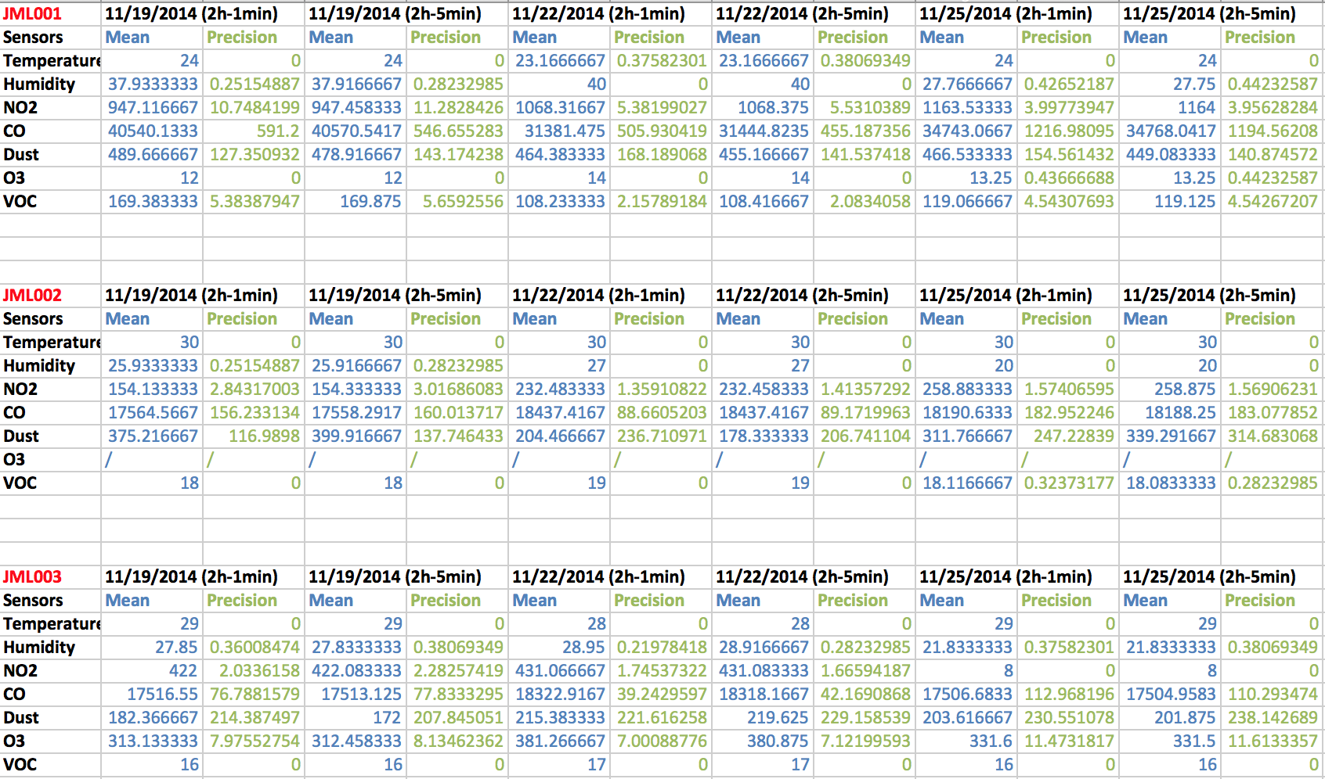

**Annex 5.** *Means and Precisions Comparison of Three Data Eggs*

**Annex 6.** *Three Eggs Nitrogen Dioxide Mean Comparison*

**Annex 7.** *Three Eggs Carbon Monoxide Mean Comparison*

**Annex 8.** *Three Eggs Dust Mean Comparison*

**Annex 9.** *Three Eggs Ozone Mean Comparison*

**Annex 10.** *Three Eggs Volatile Organics Mean Comparison*

**Annex 11.** *First Three Eggs Comparison: Nitrogen Dioxide*

**Annex 12.** *First Three Eggs Comparison: Carbon Monoxide*

**Annex 13.** *First Three Eggs Comparison: Dust*

**Annex 14.** *First Three Eggs Comparison: Ozone*

**Annex 15.** *First Three Eggs Comparison: Volatile Organics*

**Annex 16.** *Second Three Eggs Comparison: Nitrogen Dioxide*

**Annex 17.** *Second Three Eggs Comparison: Carbon Monoxide*

**Annex 18.** *Second Three Eggs Comparison: Dust*

**Annex 19.** *Second Three Eggs Comparison: Ozone*

**Annex 20.** *Second Three Eggs Comparison: Volatile Organics*